ASSIGNMENT – 13

Q1. Implementation Prim's Minimum Spanning Tree Algorithm.

#include <stdio.h>
#define INF 9999

int main() {
int n;
printf("Enter number of vertices: ");
scanf("%d",&n);

int graph[n][n];
printf("Enter adjacency matrix:\n");
for(int i=0;i<n;i++)
for(int j=0;j<n;j++)
scanf("%d",&graph[i][j]);

int selected[n], edges=0, min, x, y, totalCost=0;
for(int i=0;i<n;i++) selected[i]=0;

selected[0]=1;
printf("Edges in MST:\n");

while(edges < n-1){
min = INF;
for(int i=0;i<n;i++){
if(selected[i]){
for(int j=0;j<n;j++){
if(!selected[j] && graph[i][j]){
if(graph[i][j] < min){
min = graph[i][j];
x = i;
y = j;
}
}
}
}
}
printf("%d - %d : %d\n", x, y, min);
selected[y] = 1;
totalCost += min;
edges++;
}
printf("Minimum Cost of MST: %d\n", totalCost);
return 0;
}
Output:
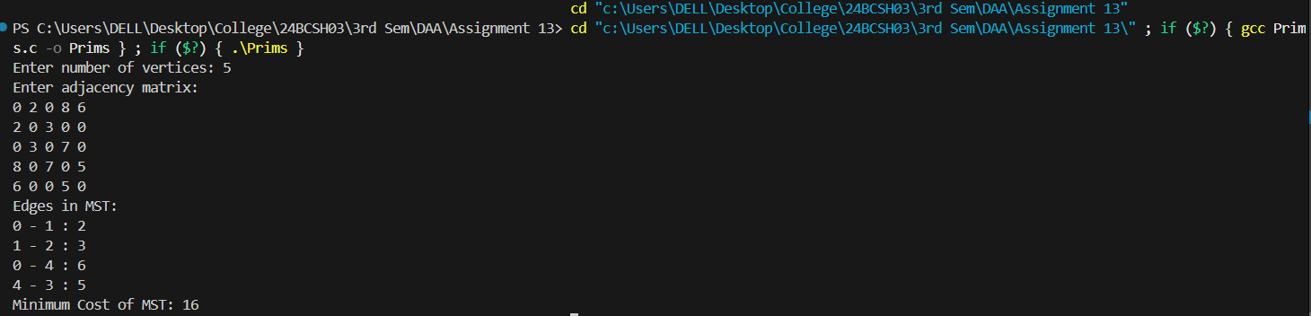

Q2. Implementation Kruskal Minimum Spanning Tree Algorithm.
#include <stdio.h>
#define INF 9999

int find(int parent[], int i){
if(parent[i]==i) return i;
return parent[i] = find(parent, parent[i]);
}

void unionSet(int parent[], int x, int y){
parent[y] = x;
}

int main() {
int n;
printf("Enter number of vertices: ");
scanf("%d",&n);

int graph[n][n];
printf("Enter adjacency matrix (0 if no edge):\n");
for(int i=0;i<n;i++)
for(int j=0;j<n;j++)
scanf("%d",&graph[i][j]);

int parent[n];
for(int i=0;i<n;i++) parent[i]=i;

int edgesInMST = 0, totalCost = 0;
printf("Edges in MST:\n");

while(edgesInMST < n-1){
int min = INF, x=-1, y=-1;
for(int i=0;i<n;i++){
for(int j=0;j<n;j++){
if(graph[i][j] && graph[i][j]<min){
min = graph[i][j];
x=i; y=j;
}
}
}

if(x==-1) break;

int set_x = find(parent,x);
int set_y = find(parent,y);
if(set_x != set_y){
printf("%d - %d : %d\n", x, y, min);
unionSet(parent,set_x,set_y);
totalCost += min;
edgesInMST++;
}

graph[x][y] = graph[y][x] = 0;
}

printf("Minimum Cost of MST: %d\n", totalCost);
return 0;
}
Output:
